HUAWEI
GRA-L09V100R001C900B132CUSTC432D001
Software Upgrade Guideline

Prepared by | 李贤 | Date | 2015-06-06
Reviewed by | CMO | Date | 2015-06-06
Approved by | CMO | Date | 2015-06-06

Huawei Technologies Co., Ltd.
All rights reserved
Contents
Contents 2
1 Version introduction 2
1.1 The following versions can be upgraded. 2
1.2 Upgrade package 3
2 Upgrade environment requirements 3
2.1 Check current upgrade environment 3
3 Upgrade introduction 3
4 Upgrade operations 4
4.1 Normal upgrade 4
4.2 Force upgrade 5
4.3 Exceptions 6
5 Upgrade validate 7
5.1 Check the version 7

Version introduction

The following versions can be upgraded.
Versions can be upgraded
GRA-L09V100R001C900B132

Upgrade package
Upgrade package | Info
Main package | \dload\UPDATE.APP
Vendor package | \vendor\UPDATE.APP
Video resource pack(optional) | Grace_common_share01.zip
Upgrade tools | Micro SD card

Upgrade environment requirements

Check current upgrade environment
- To make sure that the Micro SD card is available and can be read and write.
Notes: A Micro SD card of 4GB or more should be available. It is recommended that The Micro SD card is made by Sandisk, Kingstone, or Kingmax .
- To make sure that the power of the battery is enough to run the upgrade process. It is recommended that the power of the battery is more than 30%.
- Upgrade operations will erase all user data. So if there are some important information, you should backup them before upgrade.
- If the path of main package is a .zip file in chapter 1.2, you should unzip the .zip file firstly, and get out UPDATE.APP to do upgrade operation.

Upgrade introduction
There are two methods to upgrade: normal upgrade and force upgrade.
Normal upgrade needs to start the handset and enter the System Update module. Force upgrade is just used when the handset can’t boot up or can’t enter the idle screen.

Upgrade operations

Normal upgrade
- Format the Micro SD card (This operation is optional).
- Copy the Software: main package UPDATE.APP to a directory named dload.
- Copy the entire dload folder (with UPDATE.APP in it) to the root directory of the Micro SD card.
- Insert the Micro SD card into the handset and power on. After entering the home screen, To find System Update application, press Settings->Updates->System updates->Local update->Confirm->Upgrade to start the upgrade. Please reference to the following pictures :
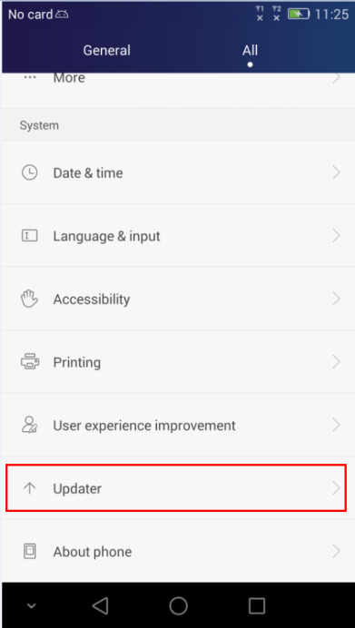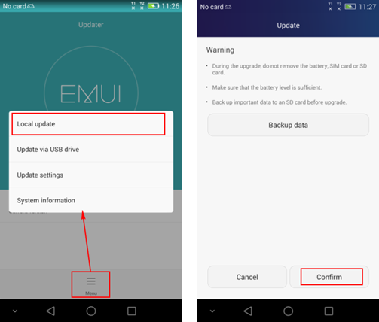

- When the progress bar stop, the phone will restart automatically.
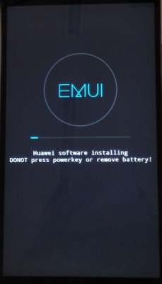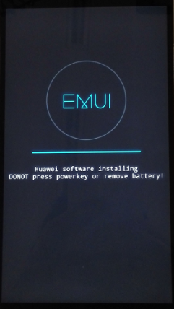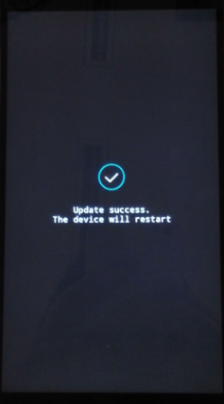
- Please copy the Software: vendor package UPDATE.APP to a directory named dload. Then execute Step 2 – Step 5 repeatedly. This step is needed only when the version is upgraded by test member.

Force upgrade
- Format the Micro SD card (This operation is optional).
- Copy the Software: main package to a directory named dload.
- Copy the entire dload folder (with UPDATE.APP in it) to the root directory of the Micro SD card.
- Make sure your handset is power off. Insert the Micro SD card into the handset. Press the VOLUME UP and VOLUME DOWN key, and then press the POWER key to power on the phone and enter the Software Upgrade Mode.
- When the progress bar stop, the phone will restart automatically.
- Please copy the Software: vendor package UPDATE.APP to a directory named dload. Then Execute Step 2 – Step 5 repeatedly. This step is needed only when the version is upgraded by test member.

Exceptions
If upgrading fail, the screen shows as below with the failure cause. For example, the fail in the figure shows that there is a software version control problems, you should firstly upgrade a transfer package provided by R&D.
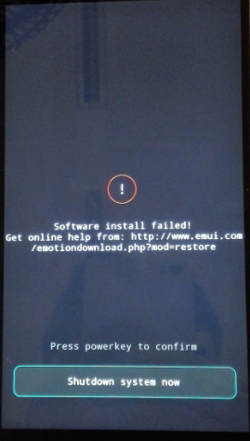

Upgrade validate

Check the version
      - By step: Settings->About phone->Build number, to check the version is correct or not.
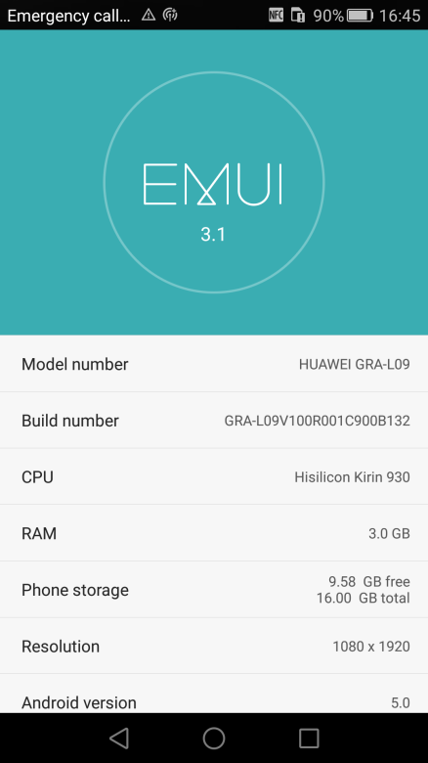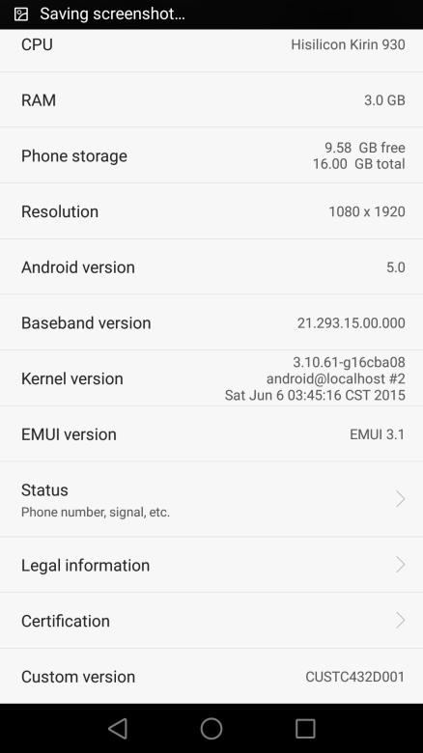

Preset video resource pack

Instruction
Put the Grace_common_share01.zip to the root directory of the MICRO SD card. Then run sscom32.exe and run the command “AT^RESOURCEVER=DataC00B001”.
And restore factory(input: *#*#2846579#*#* -〉5.Restore Factory) to copy prefabricated video resource pack.

Interface display during copying video resource pack
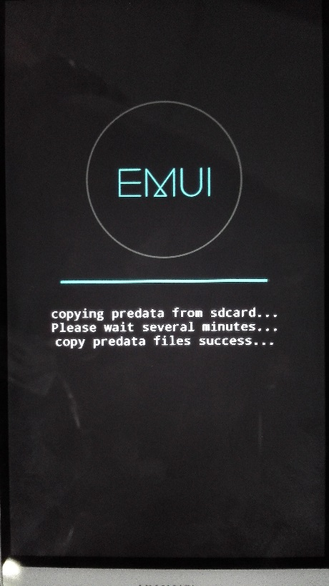
The color of font may have difference, copy takes approximately 2 minutes.

Interface display when copy is complete
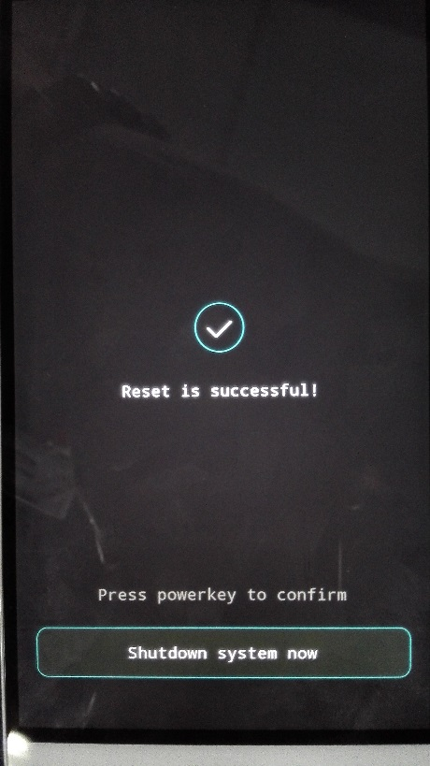
Copy has finished, press the power button to shut down.

